Lab 2: if Statement

Setup
- Open your lab repository using bitbucket and click the “+” button.
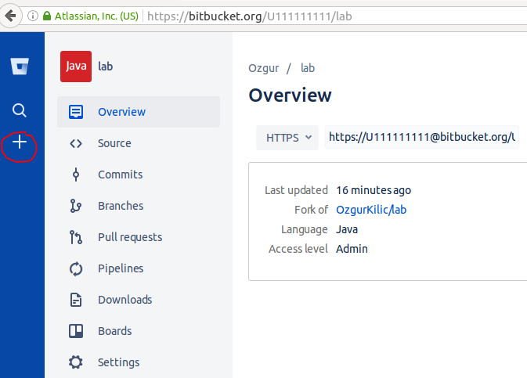

- Then click the “Compare” link as shown below.
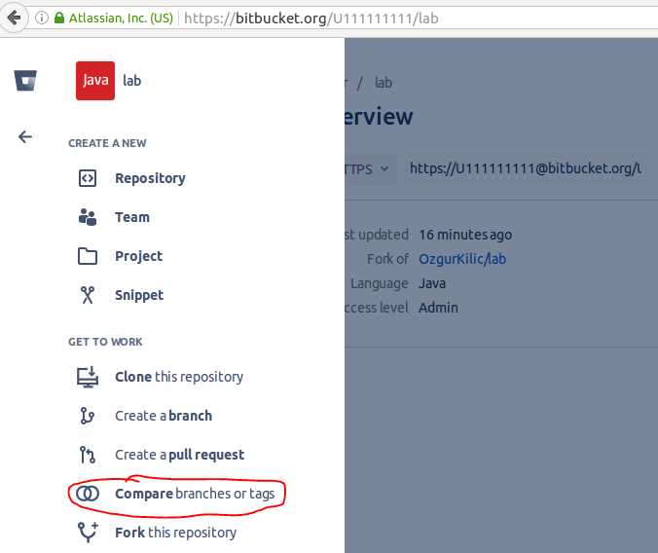

- Clik the arrows icon to swap the source and destination as shown below.

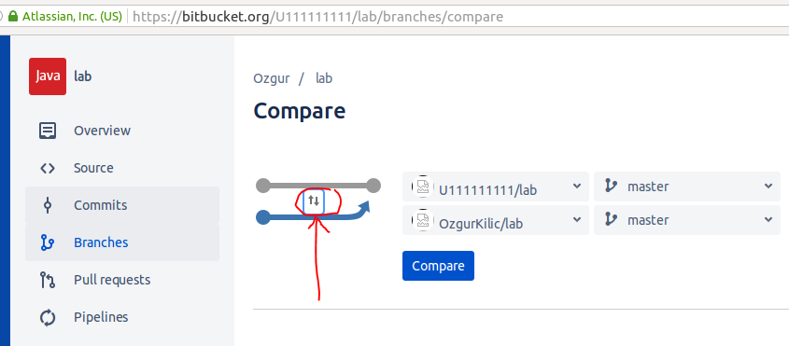

- Then Click the “Compare” button.
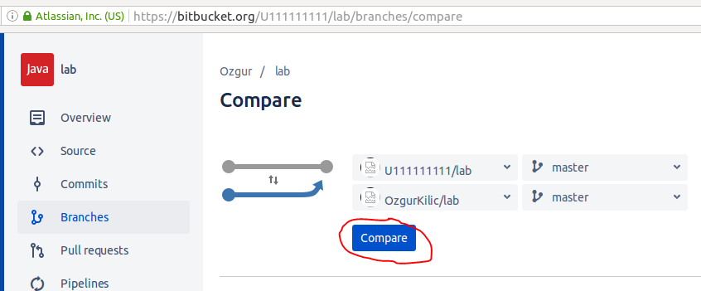

- Click the “Merge” button on the right hand side as shown below. If you don’t see the Merge button, go to step 8 and make sure you have week2 folder in your repository source.
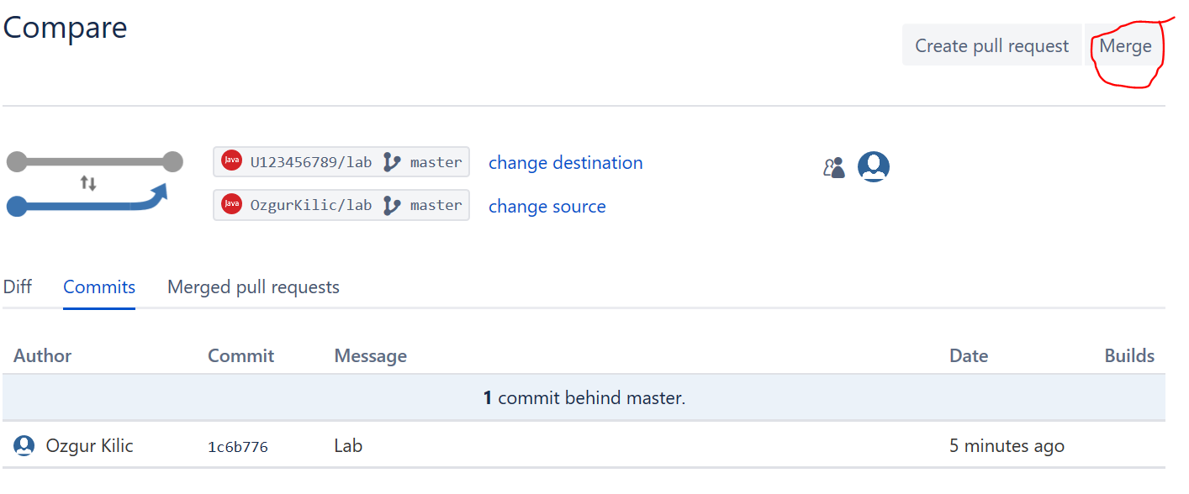
- In the next window you should see Source as tugbasuzek/week2 and Destination as UYourId/lab as shown below. Then click the “Merge” button in the dialog box.

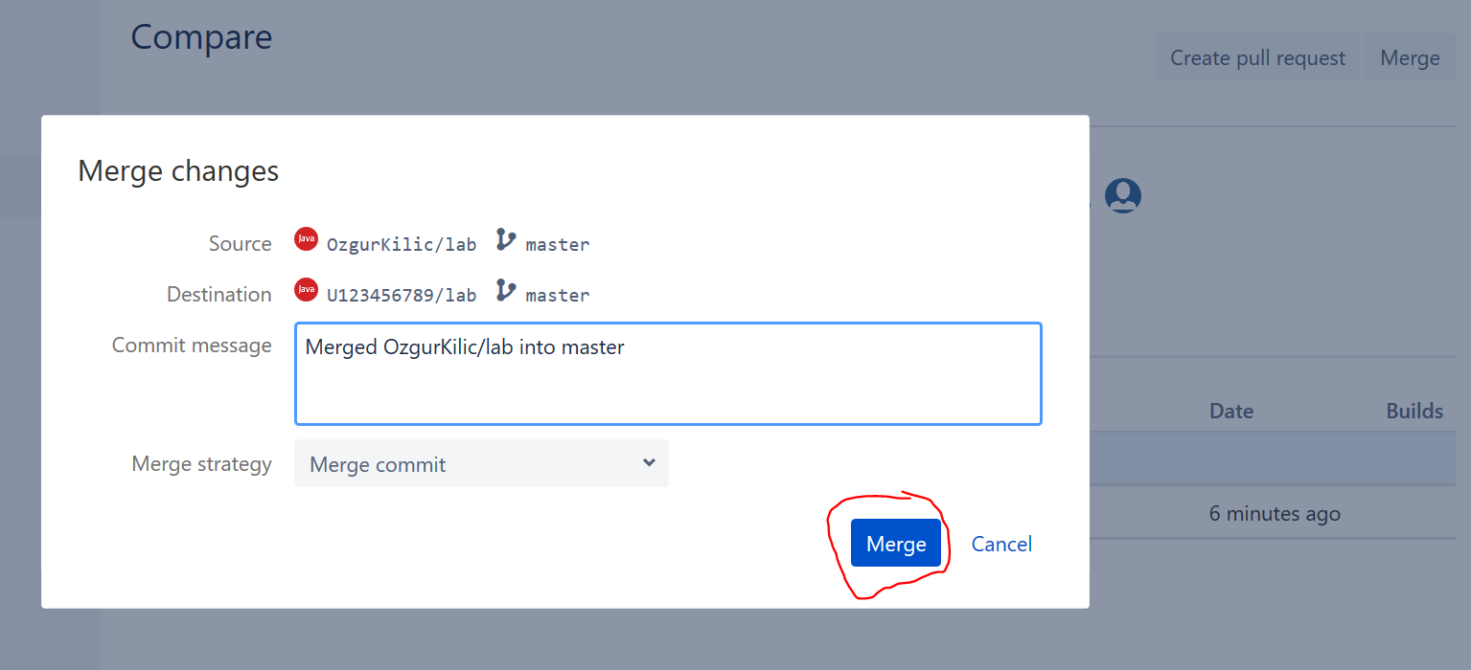

- Click the “Approve” button as shown below.

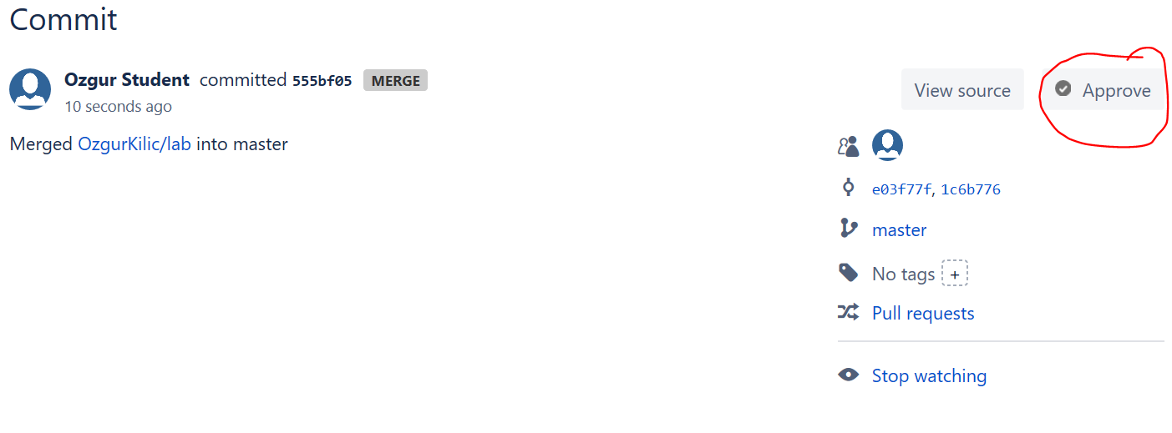

- Click the “Source” button of your repository, you should see two new folders “week2” and “week1”.
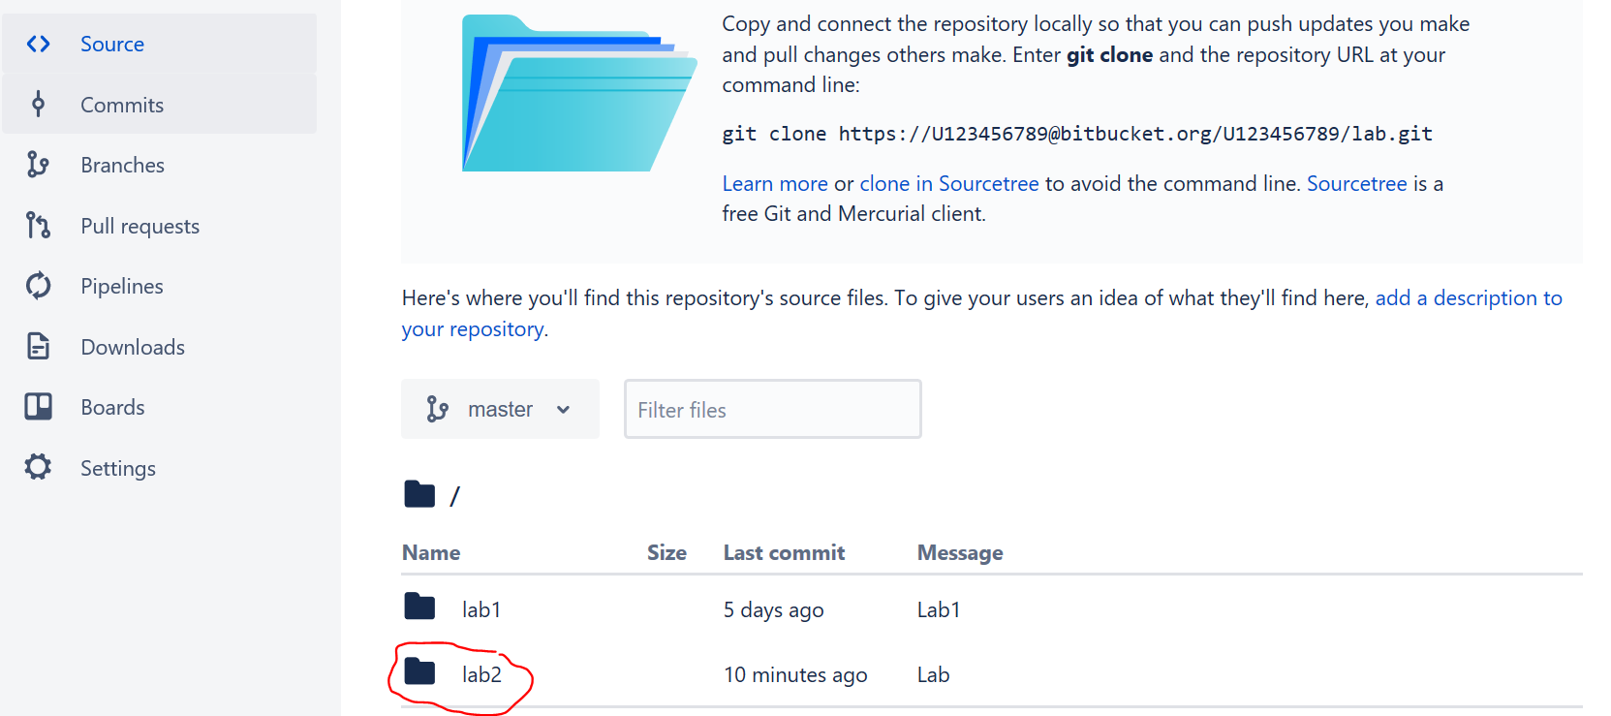

- In command line, change directory to lab directory which was created after cloning your repository. If you haven’t cloned your repository, you should clone it as described in previous lab.
Clone lab repository to your machine
- Create a directory named workspace in your home folder
- In workspace folder enter the following command, but replace username with your actual user or replace the link with your repository link.
git clone https://username@bitbucket.org/username/week2.git

- If you have already a local repository, execute the following command in the lab directory.
git pull
- Change directory to week2

Submitting code to repository
Inside week2 folder execute the following commands:
git add *.java
git commit -m "week2"
git push -u origin master

NOTE: Your lab will not be graded if
- Your account name does not have the U1111 format
- Your repository name is not week2
- Your files have compilation errors
- You haven’t completed the steps described in exercises
- Your added/modified files are not submitted to Bitbucket.
  - You have to add commit and push files as described last week

